How to install R and R studio

1. Install R first – download the version for your computer from -  
    <https://cran.r-project.org/>
   1. This is the guts of the system and I refer to it as Base R
2. Then install R studio from -  
    <https://posit.co/download/rstudio-desktop/>
   1. Note that they have a link to R at the top as well
3. If you have a PC you will need to install RTools from -   
   <https://cran.r-project.org/bin/windows/Rtools/rtools42/rtools.html>
4. Make sure you can start RStudio and that it opens on your computer
   1. You should see something like this
   2. Graphical user interface, text, application, email

      Description automatically generated
5. If you are feeling really up for it you can click the green plus sign in the upper left and create a new script  
     
   or you can click FILE – OPEN and open the attached “install packages.R” file
   1. Graphical user interface, text, application, email

      Description automatically generated
   2. The screen will look like this now
   3. Graphical user interface, text, application, email

      Description automatically generated
   4. Copy the following code from below and paste it into the upper left window   
      or you can click FILE – OPEN and open the attached “install packages.R” file

# # Libraries I use on a regular basis-----

install.packages("devtools") # install new things

install.packages("tidyverse") # dplyr and piping and ggplot etc.

install.packages("lubridate") # dates and times

install.packages("scales") # scales on ggplot ases

install.packages("readxl") # read in excel files

install.packages("skimr") # quick summary stats

install.packages("janitor") # clean up excel imports

install.packages("patchwork") # arrange multiple plots per page

install.packages("ggThemeAssist") # helps reformat code - only run library one time

install.packages("styler") # helps style your code

# Run Once and appears in Addins ----

library(styler)

library(ggThemeAssist)

* 1. It should look like this

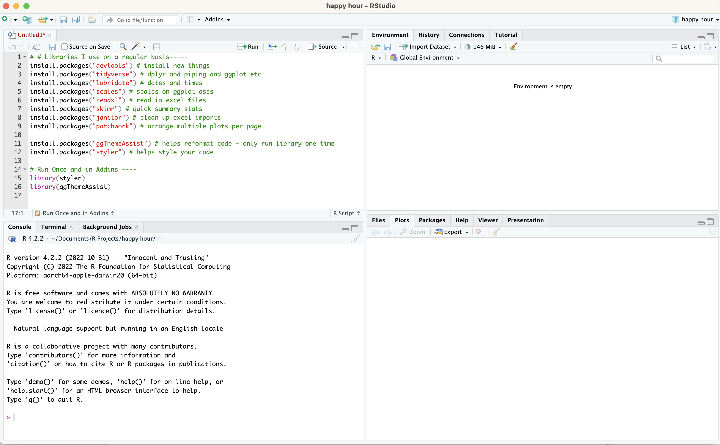

* 1. You can move the cursor to line 1 (a comment) and click the green run button in the upper right of the window or on a PC hold down the CTRL + RETURN Button or on a mac the COMMAND + RETURN button
  2. This will install a lot of the packages we will run this term.